[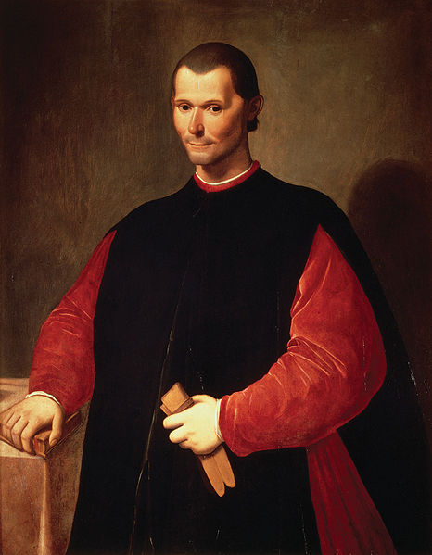](http://upload.wikimedia.org/wikipedia/commons/e/e2/Portrait_of_Niccol%C3%B2_Machiavelli_by_Santi_di_Tito.jpg)

Florence Daily Item May 8, 1522

Florence’s Favorite Advice ColumN



“Ask Niccolo”

Dear Niccolo,

I have created over 200 laws for my citizens to follow. Many of these have punishments that end in death. While I believe that these laws make for a well-ordered society, I suspect my people fear me more then the love me. Should I start easing up on them in order to be well-liked?

-Hammurabi, Babylon

Dear, Hammurabi,

________________________________________________________________________...

Dear Niccolo,

I’m a mayor of a big city and I’m faced with a very tough decision. My city is faced with a major energy crisis and the only way to solve it will be to build a hydro-electric dam. The dam would solve the crisis but it would also flood the valley, hurt the environment and destroy dozens of houses in the neighboring town. While I want to be a hero to my city, I also don’t want to be seen as a bad guy to the few people I’d hurt. What should I do?

-Waffling in Washington

Dear, Waffling,

_________________________________________________________________...

Dear Niccolo,

I’m a college football coach that demands maximum effort from my players. I make them practice for hours a day and make them run sprints until they collapse. Personally, I hate exercise and I haven’t even jogged in years. I want to be a role model to my players, but I sure don’t want to start doing push-ups. What should I do to continue motivating my players without seeming like a hypocrite?

-Lazy in Louisville

Dear Lazy,

________________________________________________________________________...

Dear Niccolo,

I’m a high school principal and I’m thinking about changing my school’s policy on discipline. I believe that all my students are mature and honest and deserve my respect. Do you think I can govern my school simply by having my students sign an honor code? This code would make students promise to never cheat, vandalize, or cut class ever again. Should I take this chance on my wonderful students?

-Faithful in Fairfax

Dear Faithful,

________________________________________________________________________...

Florence Daily Item May 8, 1522



Month DAY Year

Continue newsletter text here. Continue newsletter text here. Continue newsletter text here. Continue newsletter text here. Continue newsletter text here. Continue newsletter text here. Continue newsletter text here. Continue newsletter text here.

555.555.5555

555.555.5555

555.555.5555

email@address.com

www.webaddress.com

VOL 1 ISSUE 1